

**Agentic AI: A Sales Team Guide to Smart Implementation**

Agentic AI represents the next evolution of artificial intelligence - systems that can act autonomously, make decisions, and execute complex tasks with minimal human intervention. Unlike traditional AI that simply responds to prompts, agentic AI can reason, plan multiple steps ahead, and adapt to changing situations while working toward specific goals[1][2].

Understanding when and how to recommend agentic AI to clients requires a clear framework that balances two critical factors: complexity versus value, and control versus autonomy. This guide provides practical tools to help sales teams identify winning opportunities while avoiding costly mistakes.

**What Makes Agentic AI Different**

Traditional AI systems follow predetermined rules and require constant human input to function[3]. Agentic AI breaks free from these limitations by incorporating five key capabilities that work together autonomously[4]:

**Perception** - The system continuously monitors data streams, sensors, and changing environments to understand current conditions[4]. For example, an agentic supply chain system tracks inventory levels, weather patterns, shipping delays, and demand fluctuations simultaneously.

**Reasoning** - Using large language models and advanced algorithms, the system analyzes complex scenarios and generates solutions[4]. Rather than following a script, it evaluates multiple options and chooses the best approach based on current circumstances.

**Action** - The system executes decisions by connecting to external tools, APIs, and business systems[4]. It can send emails, update databases, place orders, or trigger workflows without human intervention.

**Learning** - Each interaction improves future performance through continuous feedback and adaptation[4]. The system gets smarter over time, recognizing patterns and refining its decision-making capabilities.

**Collaboration** - Multiple agents can work together, sharing information and coordinating actions to achieve larger objectives[4]. This creates a network effect where the whole system becomes more intelligent than individual components.

**The Complexity vs Value Framework**

The most critical skill for sales professionals is identifying which agentic AI opportunities deliver maximum business impact with manageable implementation risk. The complexity versus value framework provides a simple but powerful tool for this assessment[5][6].

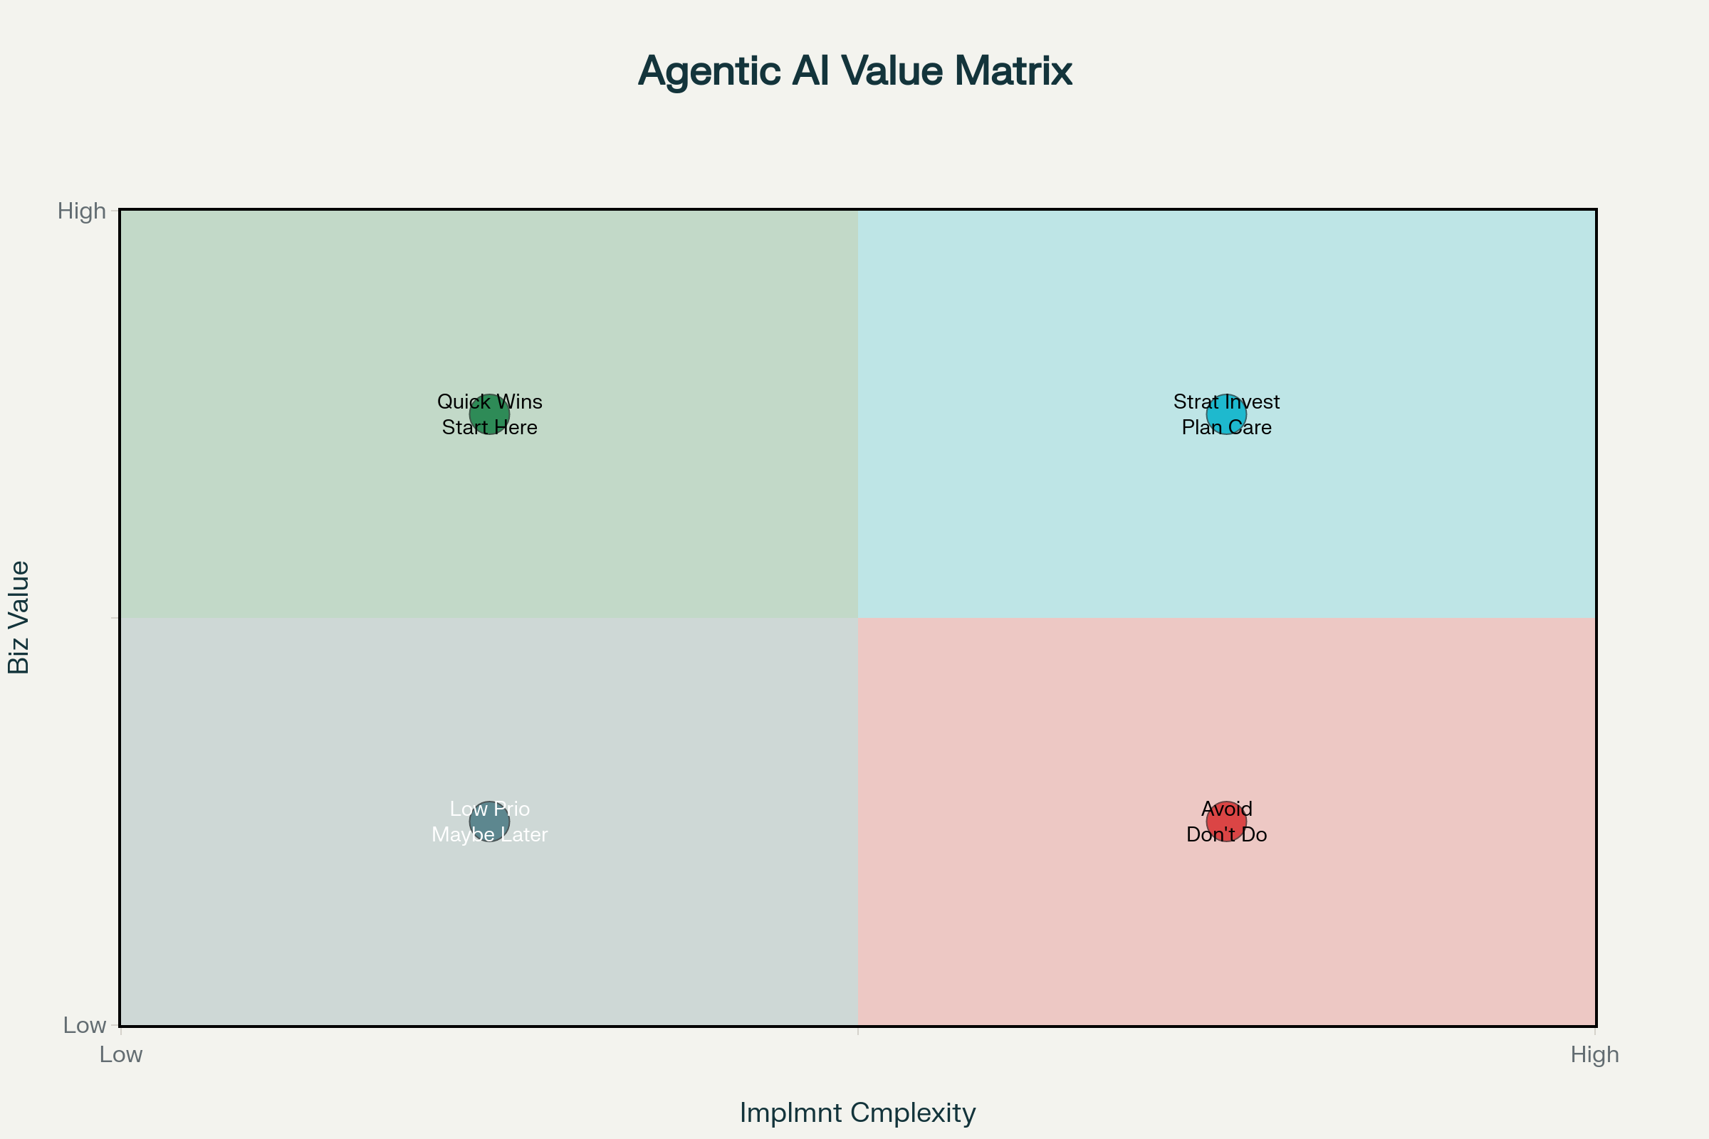

Complexity vs Value Framework for Agentic AI Decision Making

**Quick Wins (High Value, Low Complexity)**

These opportunities should be your primary focus when introducing clients to agentic AI. They deliver immediate, measurable results while building organizational confidence in AI capabilities[5][7].

**Customer Service Automation** represents the strongest quick win opportunity. A global telecom company implemented AI agents to handle tier-1 customer queries, achieving 80% cost reduction and processing 70% of inquiries automatically within six months[8]. The system handles routine questions, escalates complex issues to humans, and continuously learns from interactions.

**Data Entry and Processing** eliminates repetitive manual work that consumes valuable employee time[9]. AI agents can extract information from documents, update multiple systems simultaneously, and maintain accuracy rates above 95% while working 24/7.

**Email Routing and Basic Workflow Automation** streamlines internal processes with minimal technical complexity[10]. Agents can categorize incoming messages, assign tasks to appropriate team members, and trigger follow-up actions based on predefined business rules.

**Strategic Investments (High Value, High Complexity)**

These initiatives require careful planning and significant resources but can transform entire business operations[5][11]. They're ideal for established clients ready to make substantial AI investments.

**Autonomous Supply Chain Management** optimizes inventory, predicts demand, and automatically adjusts procurement based on market conditions[3]. Walmart's AI-driven inventory system processes data from 4,700 stores in real-time, delivering a 22% increase in e-commerce revenue[12].

**Predictive Maintenance Systems** prevent equipment failures before they occur, extending asset lifespans and reducing downtime[8]. A German automotive plant reduced unplanned downtime by 40%, saving $6.4 million annually through AI-powered equipment monitoring.

**Complex Decision Making Systems** handle multi-variable scenarios that traditionally require expert human judgment[13]. JPMorgan's Contract Intelligence system processes 12,000 commercial credit agreements annually, reducing the work that previously required 360,000 lawyer-hours while cutting error rates by 80%[12].

**Low Priority (Low Value, Low Complexity)**

While these applications are technically feasible, they don't justify the investment in agentic AI capabilities[5]. Traditional automation tools often provide better cost-effectiveness for simple tasks.

**Basic Notifications and Alerts** can be handled by simpler rule-based systems without the overhead of AI infrastructure[14]. The complexity of agentic AI provides no additional value for straightforward if-then scenarios.

**Simple Status Updates** require minimal intelligence and don't benefit from learning or adaptation capabilities[14]. Traditional workflow tools handle these requirements more efficiently.

**Avoid Zone (High Complexity, Low Value)**

These scenarios represent the biggest risk for failed AI implementations. They consume significant resources while delivering minimal business impact[14][15].

**Over-engineered Solutions** often result from "technology for technology's sake" thinking[14]. When clients want to use AI simply because it's trendy, rather than solving a genuine business problem, the project typically fails to deliver meaningful ROI.

**Complex but Non-critical Tasks** may seem impressive technically but don't move the business forward[5]. Before recommending any high-complexity solution, ensure it addresses a core business objective that significantly impacts revenue, costs, or competitive advantage.

**The Control vs Autonomy Framework**

Understanding the relationship between human oversight and AI independence helps determine the appropriate level of autonomy for different use cases[16][17][18]. This framework guides implementation decisions and sets proper client expectations.

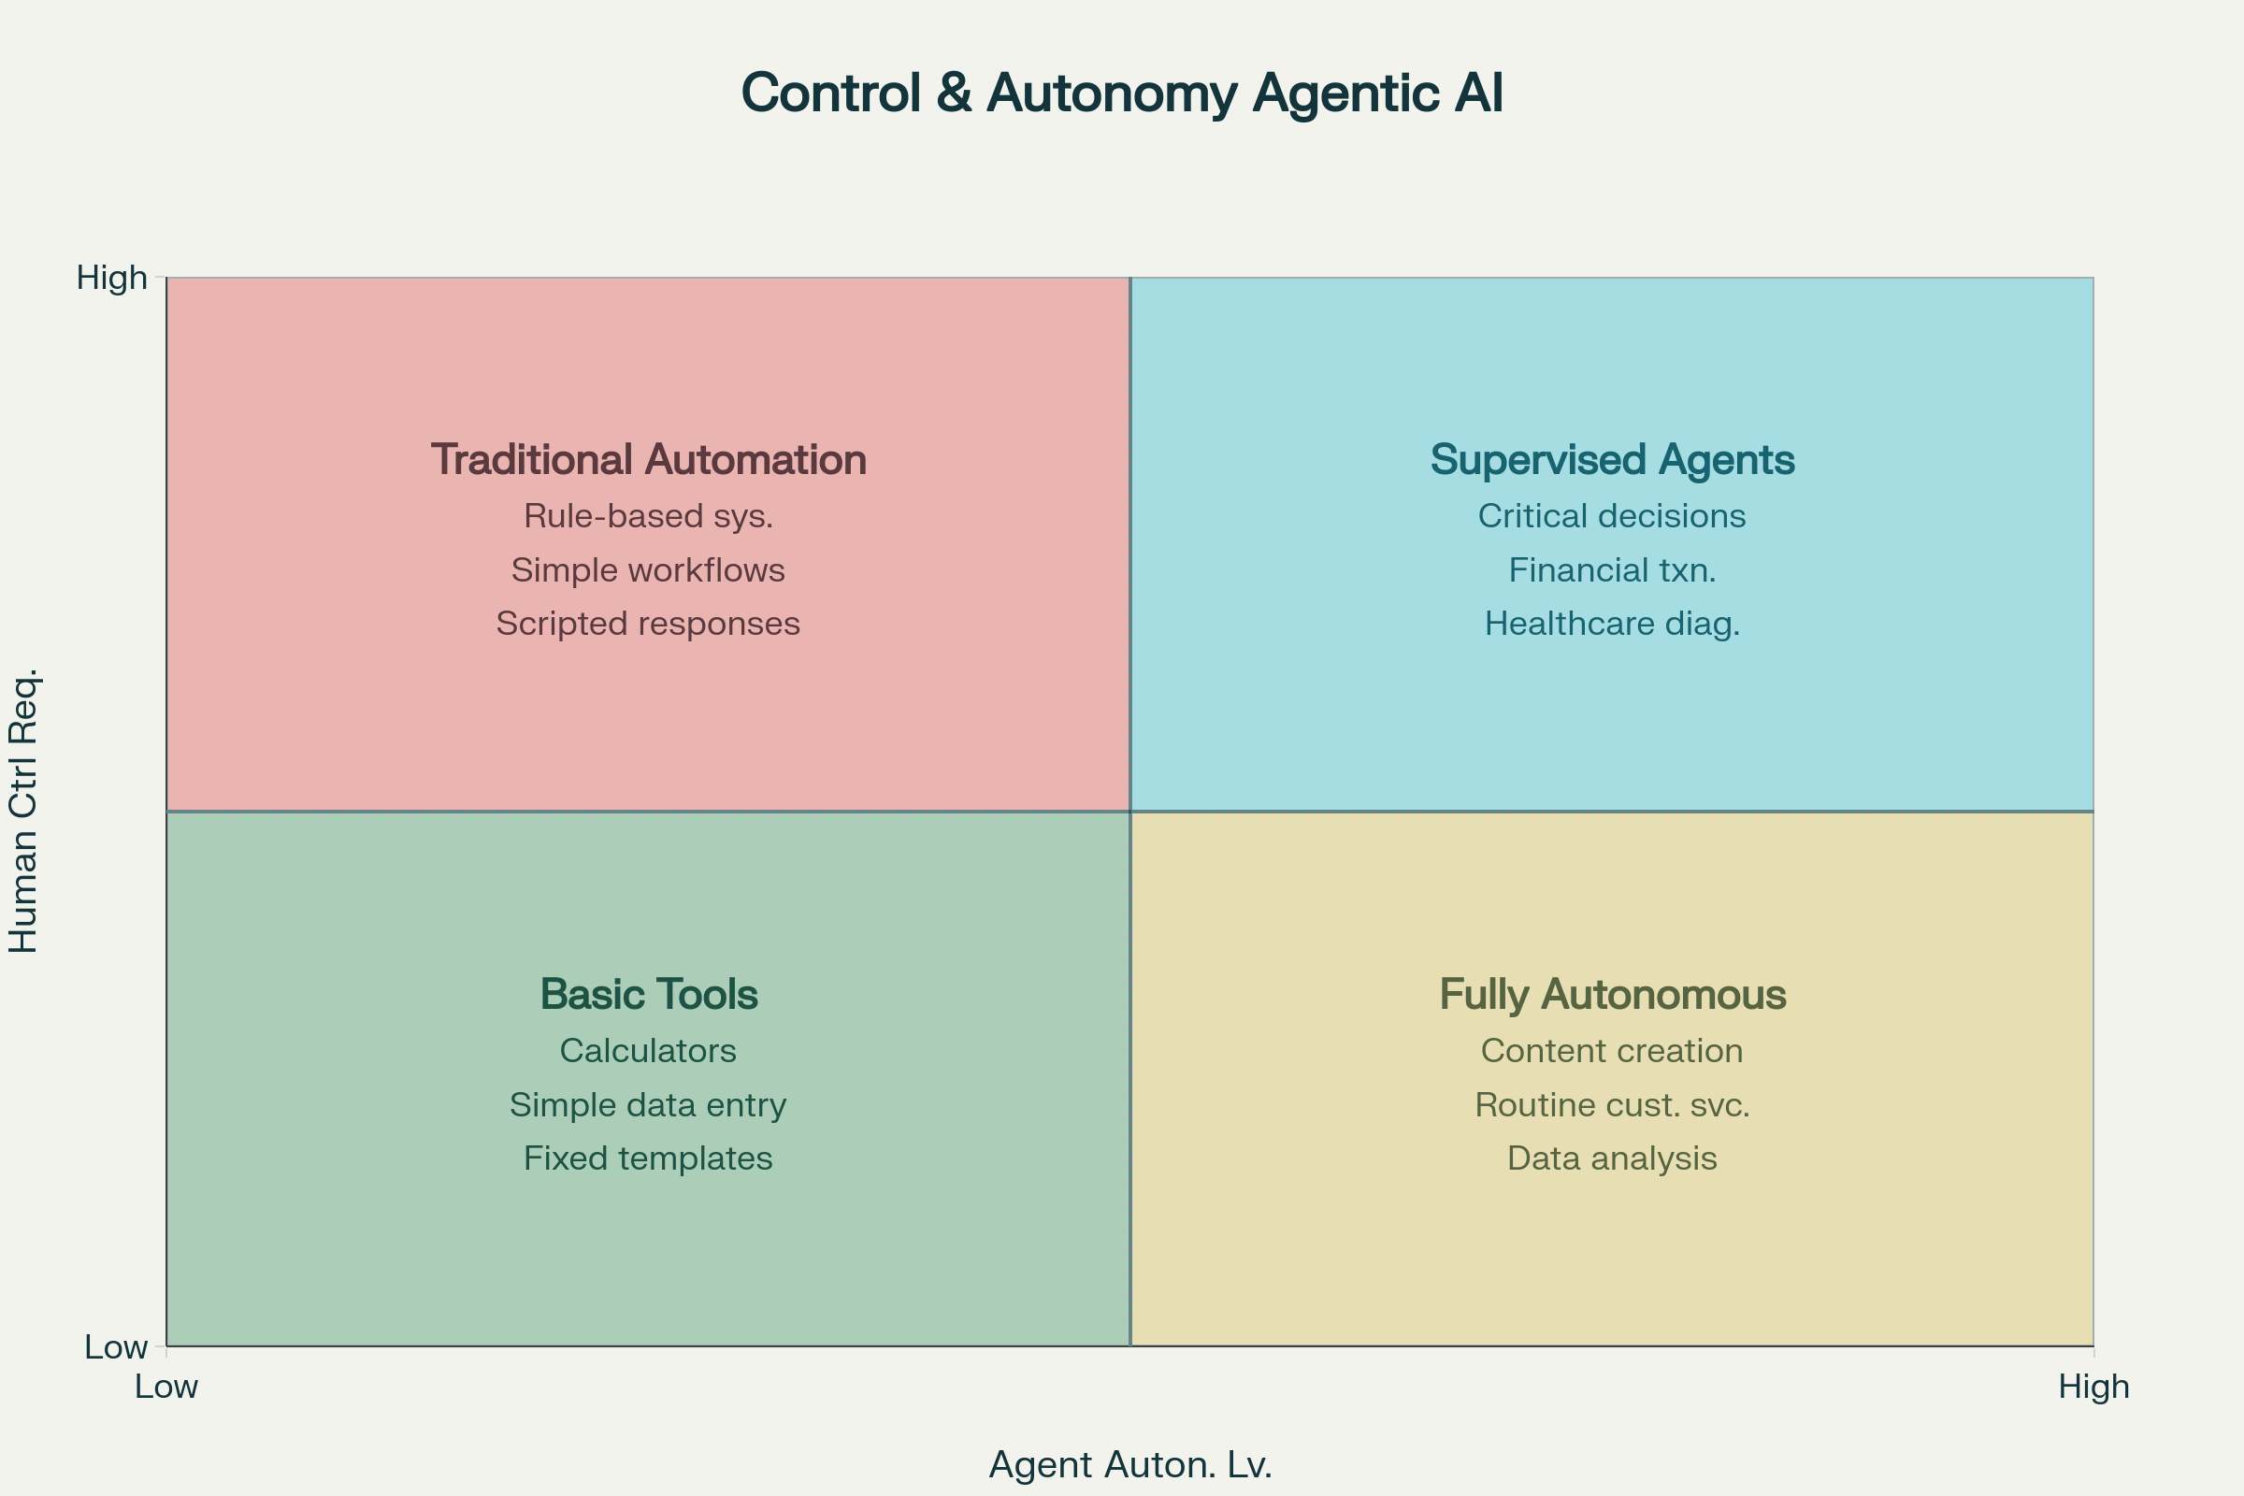

Control vs Autonomy Framework for Agentic AI Implementation

**Traditional Automation (High Control, Low Autonomy)**

These systems follow predetermined rules with significant human oversight. They're appropriate for processes that require consistency but don't benefit from adaptive learning[16].

**Rule-based Systems** excel at repetitive tasks with clear, unchanging procedures. They provide predictable outcomes and maintain human control over all decision points[19].

**Simple Workflows** automate routine processes while keeping humans in the decision loop. Email filtering, basic data validation, and standard approval processes fit this category[19].

**Scripted Responses** handle common scenarios with pre-approved answers. Customer service chatbots that follow decision trees exemplify this approach[19].

**Supervised Agents (High Control, High Autonomy)**

This quadrant represents the sweet spot for many enterprise applications. AI agents can make sophisticated decisions while maintaining human oversight for critical situations[17][18].

**Critical Business Decisions** benefit from AI analysis and recommendations while requiring human approval before execution[14]. Financial institutions use this approach for loan approvals, where AI evaluates applications but humans make final decisions on complex cases.

**Healthcare Diagnosis Support** leverages AI's pattern recognition capabilities while maintaining physician oversight[20]. AI agents can analyze medical images and patient data to suggest diagnoses, but doctors retain final authority over treatment decisions.

**Financial Transactions** above certain thresholds require human approval[21]. AI agents can process routine transactions autonomously but escalate high-value or unusual transactions for human review.

**Basic Tools (Low Control, Low Autonomy)**

Simple tools that require minimal oversight and provide limited intelligence. These don't qualify as agentic AI but serve as stepping stones toward more sophisticated implementations[19].

**Calculators and Simple Analytics** provide computational support without learning or adaptation[19]. They serve specific functions but don't evolve or make autonomous decisions.

**Data Entry Tools** streamline manual processes without introducing intelligence or decision-making capabilities[19].

**Fully Autonomous (Low Control, High Autonomy)**

These systems operate independently with minimal human intervention. They're suitable for routine tasks where errors have limited consequences[17][18].

**Content Creation** leverages AI's creative capabilities for marketing materials, product descriptions, and social media posts[9]. H&M's virtual shopping assistant demonstrates this approach, generating personalized recommendations and handling customer interactions with minimal oversight[22].

**Routine Customer Service** handles common inquiries without human intervention. Bank of America's Erica AI assistant processes over a billion interactions annually, resolving standard banking questions while escalating complex issues[22].

**Data Analysis and Reporting** transforms raw information into actionable insights automatically. AI agents can identify trends, generate reports, and flag anomalies without constant supervision[9].

**Understanding Business Value Drivers**

Successful agentic AI implementations deliver value through multiple channels that compound over time[23]. Understanding these value drivers helps sales teams articulate concrete benefits to prospects.

**Operational Efficiency and Cost Reduction**

The most immediate and measurable benefit comes from automating labor-intensive processes[23]. Companies typically see 3-6x ROI within the first year by reducing manual work and eliminating errors[24][8].

**Labor Cost Savings** - Agentic AI handles tasks that previously required human workers, freeing employees for higher-value activities[23]. A healthcare system reduced administrative time by 40%, allowing doctors to see 12% more patients while saving $10 million annually[25].

**Error Reduction** - AI systems maintain consistency and accuracy that humans struggle to match over extended periods[23]. JPMorgan's contract analysis system reduced error rates by 80% while processing 12,000 agreements annually[12].

**24/7 Operations** - Unlike human workers, AI agents operate continuously without breaks, vacations, or shift changes[23]. This constant availability improves response times and customer satisfaction while reducing operational overhead.

**Enhanced Decision Making**

AI agents process vast amounts of data to identify patterns and opportunities that humans might miss[23]. This capability becomes particularly valuable in complex, data-rich environments.

**Predictive Analytics** - AI systems analyze historical patterns to forecast future conditions, enabling proactive rather than reactive management[23]. Retailers using dynamic pricing AI agents report 12% revenue increases by automatically adjusting prices based on market conditions[8].

**Real-time Optimization** - AI agents continuously adjust strategies based on changing conditions[23]. Supply chain systems automatically reroute shipments, adjust inventory levels, and modify procurement schedules to optimize costs and service levels.

**Data-driven Insights** - AI processes information faster and more comprehensively than human analysts, uncovering opportunities and risks that might otherwise go unnoticed[23].

**Revenue Growth and Customer Experience**

While cost reduction provides immediate ROI, revenue-generating applications often deliver larger long-term value[23].

**Personalized Customer Experiences** - AI agents tailor interactions based on individual customer history, preferences, and behavior patterns[26][3]. E-commerce platforms using personalized shopping assistants report 25% increases in conversion rates[27].

**Proactive Problem Resolution** - Rather than waiting for customers to contact support, AI agents identify and resolve issues before they impact customer experience[3]. This proactive approach improves satisfaction while reducing support costs.

**New Revenue Streams** - Advanced AI capabilities can enable entirely new business models or service offerings[23]. Predictive maintenance systems often evolve into service-based revenue streams where companies monetize their AI capabilities.

**When Not to Use Agentic AI**

Recognizing inappropriate applications prevents costly failures and maintains client trust[5][14]. Several scenarios consistently lead to poor outcomes and should be avoided.

**High-Risk, Low-Error-Tolerance Scenarios**

Agentic AI's probabilistic nature makes it unsuitable for applications where errors have serious consequences[5][14].

**Life-Critical Decisions** should never be fully automated[14]. While AI can provide analysis and recommendations, human oversight remains essential for situations involving safety, legal liability, or irreversible consequences.

**Regulatory Compliance** in highly regulated industries requires explainable decision-making and clear audit trails[14]. Traditional rule-based systems often provide better compliance documentation than AI agents.

**High-Stakes Financial Transactions** need human oversight and approval processes[14]. While AI can analyze and recommend, final authorization should remain with qualified human decision-makers.

**Emotionally Sensitive Situations**

AI agents lack genuine empathy and emotional intelligence required for sensitive human interactions[14].

**Grief and Loss Support** - A customer reporting a deceased family member's account needs human compassion, not automated responses[14]. AI agents often misinterpret emotional context and provide inappropriate solutions.

**Complaint Resolution** - Frustrated customers need acknowledgment and understanding that AI cannot provide[14]. A customer reporting a defective product wants empathy and genuine problem-solving, not scripted responses and partial refunds.

**Personal Crisis Management** - Situations involving personal or financial distress require human judgment and emotional support[14].

**Simple, Well-Defined Processes**

Over-engineering simple problems with complex AI solutions wastes resources and creates unnecessary risks[5][28].

**Basic Data Entry** - If the process involves straightforward form completion or data transfer, traditional automation tools provide better cost-effectiveness[28].

**Simple Calculations** - Mathematical operations and basic analytics don't require AI intelligence[28].

**Fixed Workflows** - Processes that never change and have clear, unchanging rules work better with traditional automation[28].

**Poor Data Quality or Availability**

Agentic AI systems require high-quality, relevant data to function effectively[29][30].

**Limited Historical Data** - AI agents learn from patterns in historical information. Without sufficient data, they cannot make reliable predictions or decisions[30].

**Inconsistent Data Sources** - When information quality varies significantly across systems, AI agents may make incorrect decisions based on flawed inputs[29].

**Rapidly Changing Environments** - If business rules, processes, or objectives change frequently, AI agents may not adapt quickly enough to remain effective[30].

**Implementation Success Factors**

Converting agentic AI opportunities into successful deployments requires attention to critical success factors that differentiate winning projects from failures[15][31].

**Clear Use Case Definition**

The most common implementation mistake involves starting without a specific, measurable objective[15]. Successful projects begin with precise definitions of what the AI agent should accomplish and how success will be measured.

**Specific Problem Statement** - Rather than "improve customer service," define "reduce average response time for billing inquiries from 24 hours to 2 hours while maintaining 95% accuracy"[15].

**Measurable Success Criteria** - Establish concrete metrics that demonstrate value delivery[15]. This might include cost reduction percentages, time savings, accuracy improvements, or revenue increases.

**Defined Scope Boundaries** - Clearly specify what the AI agent will and will not handle[15]. This prevents scope creep and ensures realistic expectations.

**Data Quality and Availability**

AI agents perform only as well as the data they receive[29][30]. Successful implementations invest in data preparation and quality assurance before deployment.

**Data Audit and Cleanup** - Identify and correct inconsistencies, duplicates, and errors in training data[30]. Poor data quality inevitably leads to poor AI performance.

**Integration Planning** - Ensure AI agents can access necessary data sources and update relevant systems[15]. Technical integration challenges often derail otherwise sound AI strategies.

**Continuous Data Monitoring** - Implement systems to detect data drift and quality degradation over time[29]. AI performance deteriorates when underlying data patterns change without corresponding model updates.

**Organizational Readiness**

Technical success means nothing without organizational adoption and support[31][15].

**Stakeholder Alignment** - Ensure all affected departments understand how AI agents will change their workflows[15]. Resistance to change often undermines technically successful implementations.

**Training and Change Management** - Prepare employees for new processes and responsibilities[15]. AI agents change how work gets done, requiring updated procedures and skills.

**Governance Framework** - Establish clear policies for AI agent oversight, performance monitoring, and issue escalation[32][33]. Without proper governance, autonomous systems can create operational chaos.

**Iterative Implementation Approach**

Successful agentic AI deployments start small and expand based on proven results[31][15].

**Pilot Projects** - Begin with limited scope implementations to validate technical and business assumptions[31]. Pilots allow for learning and adjustment before full-scale deployment.

**Performance Monitoring** - Continuously track AI agent performance against established success metrics[31]. This enables rapid identification and correction of issues.

**Gradual Expansion** - Scale successful pilots to broader applications while applying lessons learned[31]. This approach minimizes risk while building organizational confidence in AI capabilities.

**ROI Calculation and Business Case Development**

Developing compelling business cases requires understanding both visible and hidden costs while accurately projecting benefits across multiple value dimensions[24][34].

**Cost Components**

Traditional AI cost estimates often underestimate total implementation expenses, leading to disappointing ROI calculations[34].

**Development and Integration Costs** - Initial system development typically ranges from $15,000 to $100,000 depending on complexity[35]. However, integration with existing systems often doubles these estimates.

**Infrastructure and Operational Costs** - Cloud computing resources, data storage, and ongoing model training create recurring expenses[34]. Agentic AI systems consume more computational resources than traditional applications due to their continuous learning and decision-making capabilities.

**Hidden Implementation Costs** - Data preparation, change management, training, and organizational disruption create additional expenses often overlooked in initial estimates[34]. These "soft costs" frequently exceed technical development costs.

**Governance and Compliance Costs** - Monitoring, auditing, and regulatory compliance require ongoing investment in processes and personnel[34].

**Benefit Quantification**

Accurate ROI calculations require measuring both direct and indirect benefits across multiple timeframes[24][23].

**Direct Cost Savings** - Labor reduction, error elimination, and process acceleration provide immediate, measurable benefits[24]. Companies typically achieve 3-6x ROI within 18 months through direct operational improvements.

**Revenue Enhancement** - Improved customer experience, faster response times, and personalized service drive revenue growth[24]. These benefits often exceed cost savings in successful implementations.

**Intangible Benefits** - Enhanced decision-making capability, competitive advantage, and organizational learning create long-term value that's difficult to quantify but contributes significantly to overall ROI[24].

**Risk Mitigation Value** - Reduced errors, improved compliance, and consistent service delivery provide insurance value that prevents future costs[24].

**ROI Timeline Expectations**

Agentic AI implementations typically follow predictable ROI patterns that help set appropriate expectations[24][36].

**Months 1-6: Investment Phase** - Initial costs exceed benefits as systems are developed, integrated, and optimized[24]. Organizations should expect negative ROI during this period.

**Months 6-12: Break-even Phase** - Direct benefits begin offsetting implementation costs[24]. Well-executed projects achieve break-even within 8-10 months.

**Months 12-24: Value Acceleration** - AI agents improve through learning while implementation costs decrease[24]. This period typically delivers the strongest ROI growth.

**Beyond 24 Months: Sustained Value** - Mature AI agents provide consistent value delivery with minimal incremental investment[24]. Long-term ROI often exceeds initial projections as systems become more capable and handle expanded responsibilities.

**Common Implementation Mistakes**

Learning from frequent failure patterns helps sales teams guide clients toward successful outcomes while avoiding predictable pitfalls[15][29][31].

**The "Super Agent" Trap**

Many organizations attempt to build one comprehensive AI agent that handles all possible scenarios[37]. This approach consistently leads to poor performance and user frustration.

**Overly Broad Scope** - Trying to solve too many problems simultaneously results in mediocre performance across all areas[37]. Successful implementations focus on specific, well-defined use cases.

**Complexity Management Issues** - Super agents become difficult to train, maintain, and troubleshoot[37]. Specialized agents performing focused tasks deliver better results.

**User Experience Problems** - Complex agents confuse users who can't predict how the system will respond to different inputs[37].

**Poor Tool Integration and Naming**

AI agents rely on external tools and systems to execute actions, but poorly designed integrations create performance problems[37].

**Generic Tool Names** - Naming tools "email system" or "CRM tool" without specificity confuses AI agents about which functions to use[37]. Clear, descriptive names improve agent decision-making accuracy.

**Inadequate Integration Testing** - API failures, timeout errors, and data format mismatches cause agent failures in production[29]. Comprehensive integration testing prevents these issues.

**Missing Error Handling** - When external systems fail, AI agents need graceful failure modes and escalation procedures[29]. Without proper error handling, single point failures cascade through the entire system.

**Inadequate Monitoring and Iteration**

Many implementations treat AI agents as "set and forget" systems rather than continuously evolving capabilities[15][30].

**Insufficient Performance Tracking** - Without detailed monitoring, organizations can't identify when AI agents drift from expected performance[15]. Regular monitoring enables proactive optimization.

**Lack of Feedback Loops** - AI agents improve through feedback, but many implementations fail to capture and process user feedback systematically[30].

**Static Configuration** - Business requirements evolve, but AI agents need updates to remain effective[30]. Successful implementations include regular review and optimization cycles.

**Unrealistic Timeline Expectations**

Expecting immediate results leads to premature project termination before AI agents have time to demonstrate value[15].

**Insufficient Training Time** - AI agents need time to learn patterns and optimize performance[15]. Rushing deployment often results in poor initial performance that improves over time.

**Inadequate Change Management** - Organizations underestimate the time required for users to adapt to new AI-assisted workflows[15]. Cultural adoption takes longer than technical implementation.

**Missing Success Milestones** - Without intermediate success metrics, stakeholders lose confidence before full benefits emerge[15]. Clear milestone tracking maintains project support through the learning period.

**Risk Management and Governance**

Implementing appropriate governance frameworks protects organizations from AI-related risks while enabling innovation and value creation[32][33][38].

**Operational Risk Controls**

Autonomous AI systems introduce new categories of operational risk that require specific controls and monitoring[38].

**Decision Boundary Management** - Clearly define which decisions AI agents can make independently versus those requiring human approval[32]. Financial thresholds, customer impact levels, and compliance requirements typically determine these boundaries.

**Performance Monitoring Systems** - Implement real-time monitoring that tracks both outcomes and decision patterns[32]. This visibility enables rapid identification of performance drift or unexpected behavior.

**Escalation Procedures** - Define clear procedures for situations where AI agents encounter scenarios beyond their capabilities[32]. Proper escalation prevents system failures from becoming business failures.

**Ethical and Compliance Considerations**

AI governance must address ethical implications and regulatory requirements that vary by industry and jurisdiction[33][39].

**Bias Detection and Mitigation** - Regularly audit AI decisions for unfair treatment of different customer segments or demographic groups[33]. Bias in training data often creates systemic discrimination in AI outputs.

**Data Privacy and Security** - Ensure AI agents handle personal and sensitive data according to applicable regulations[39]. GDPR, HIPAA, and industry-specific requirements create compliance obligations for AI systems.

**Explainability Requirements** - Some decisions require clear explanations of AI reasoning for regulatory compliance or customer trust[33]. Not all AI applications can operate as "black boxes."

**Trust Building Strategies**

Successful AI implementations build stakeholder confidence through transparency and consistent performance[33][38].

**Transparent Communication** - Clearly explain to customers and employees when they're interacting with AI agents[33]. Hidden AI often creates trust issues when discovered.

**Gradual Autonomy Expansion** - Start with limited AI authority and expand capabilities as systems prove reliable[17]. This approach builds confidence while minimizing risk exposure.

**Human Override Capability** - Always maintain the ability for humans to intervene in AI decisions when necessary[33]. This safety net is essential for maintaining trust and handling exceptional situations.

**Industry-Specific Considerations**

Different industries present unique opportunities, challenges, and constraints that influence agentic AI implementation strategies[40][20][12].

**Financial Services**

Financial institutions face strict regulatory requirements while handling high-stakes decisions that create both opportunities and constraints[20][22].

**Fraud Detection and Prevention** - AI agents excel at identifying suspicious transaction patterns and account activities[20]. Real-time analysis enables immediate response to potential fraud while reducing false positives.

**Customer Service Automation** - Bank of America's Erica demonstrates the potential for AI agents in routine banking interactions[22]. The system handles over a billion customer interactions annually while escalating complex issues to human agents.

**Compliance and Risk Management** - AI agents can monitor transactions for regulatory compliance and risk thresholds[20]. However, final decisions on significant transactions typically require human oversight due to liability concerns.

**Healthcare and Life Sciences**

Healthcare applications offer significant value potential while requiring careful attention to safety and regulatory compliance[20].

**Clinical Decision Support** - AI agents analyze medical images, patient history, and symptoms to support diagnostic decisions[20]. However, physicians retain final authority over patient care decisions.

**Administrative Automation** - Healthcare systems use AI agents to automate appointment scheduling, insurance verification, and documentation[8]. A U.S. healthcare system reduced administrative time by 40% while improving patient care metrics.

**Drug Discovery and Research** - AI agents accelerate research by identifying promising compounds and optimizing clinical trial designs[20]. These applications offer substantial value but require long development timelines.

**Retail and E-commerce**

Retail organizations leverage AI agents to enhance customer experience and optimize operations[26][27][22].

**Personalized Shopping Assistance** - AI agents analyze customer behavior, preferences, and purchase history to provide tailored product recommendations[26][22]. H&M's virtual shopping assistant increased conversion rates by 25% while reducing support costs.

**Inventory and Supply Chain Optimization** - AI agents predict demand, optimize inventory levels, and coordinate supplier relationships[12]. Walmart's AI-driven system processes data from thousands of stores to optimize inventory placement and replenishment.

**Dynamic Pricing** - AI agents automatically adjust prices based on market conditions, competition, and demand patterns[8]. Fashion retailers report 12% revenue increases through AI-powered pricing optimization.

**Manufacturing and Industrial**

Manufacturing applications focus on operational efficiency, predictive maintenance, and quality control[8][40].

**Predictive Maintenance** - AI agents analyze equipment sensor data to predict failures before they occur[8]. A German automotive plant reduced downtime by 40%, saving $6.4 million annually through AI-powered equipment monitoring.

**Quality Control Automation** - AI agents inspect products and identify defects more consistently than human inspectors[40]. Computer vision systems integrated with agentic AI can automatically adjust production parameters to maintain quality standards.

**Supply Chain Coordination** - AI agents coordinate complex manufacturing supply chains by optimizing supplier relationships, inventory levels, and production scheduling[40].

**Future Considerations and Emerging Trends**

Understanding emerging developments in agentic AI helps sales teams position clients for long-term success while avoiding short-term technological dead ends[41][36].

**Multi-Agent System Evolution**

The future of agentic AI involves multiple specialized agents working together to accomplish complex objectives[3][41].

**Agent Specialization** - Rather than building general-purpose AI agents, organizations increasingly deploy specialized agents for specific functions[3]. Marketing agents, customer service agents, and analytical agents collaborate to deliver comprehensive solutions.

**Cross-System Integration** - Future AI agents will seamlessly integrate across multiple business systems and platforms[41]. This integration enables end-to-end process automation that spans organizational boundaries.

**Emergent Capabilities** - When multiple agents collaborate, they often develop capabilities that exceed the sum of individual agent abilities[3]. This emergent intelligence creates competitive advantages for early adopters.

**Regulatory and Compliance Evolution**

Government regulations and industry standards for AI continue developing, influencing implementation strategies[39][42].

**AI Act Compliance** - European Union regulations require specific governance frameworks for AI systems based on risk categories[39]. Organizations must design AI agents to comply with these evolving requirements.

**Industry Standards Development** - Professional associations and regulatory bodies continue developing standards for AI governance, testing, and deployment[42]. Staying current with these standards prevents future compliance issues.

**Liability and Insurance Considerations** - Legal frameworks for AI liability continue evolving, potentially requiring new insurance products and risk management approaches[38].

**Technology Advancement Implications**

Ongoing improvements in AI capabilities create new opportunities while potentially obsoleting current approaches[36][43].

**Cost Reduction Trends** - AI inference costs continue declining while capability improves[43]. However, more sophisticated agentic workflows may require more computational resources, creating complex cost dynamics.

**Capability Expansion** - New AI models demonstrate improved reasoning, planning, and execution capabilities[41]. These advances enable applications previously considered impractical or impossible.

**Integration Simplification** - Development tools and platforms increasingly simplify AI agent creation and deployment[41]. This trend reduces technical barriers while potentially commoditizing basic AI capabilities.

**Sales Team Action Items**

Converting this knowledge into sales success requires specific strategies and tools that sales professionals can immediately implement[11].

**Opportunity Qualification Framework**

Use the complexity versus value matrix during initial prospect conversations to quickly identify high-potential opportunities[11].

**Discovery Questions** - Ask prospects about repetitive, high-volume processes that require decision-making[11]. These scenarios often represent ideal agentic AI opportunities.

**Business Impact Assessment** - Quantify the current cost of manual processes in terms of labor hours, error rates, and opportunity costs[11]. This creates the foundation for ROI calculations.

**Technical Feasibility Evaluation** - Assess data availability, system integration requirements, and organizational readiness[11]. Early identification of implementation challenges prevents future project problems.

**ROI Presentation Strategies**

Develop compelling business cases that resonate with different stakeholder types[24].

**CFO-Focused Presentations** - Emphasize cost reduction, efficiency gains, and measurable ROI with clear timelines[24]. Use concrete examples from similar companies to demonstrate proven results.

**CTO-Focused Discussions** - Address technical implementation challenges, integration requirements, and scalability considerations[24]. Provide detailed implementation roadmaps and risk mitigation strategies.

**Business Unit Leader Engagement** - Focus on operational improvements, competitive advantages, and customer experience enhancements[24]. Demonstrate how agentic AI enables strategic objectives rather than just reducing costs.

**Competitive Positioning**

Position agentic AI solutions effectively against alternative approaches and competitor offerings[11].

**Traditional Automation Comparison** - Highlight agentic AI's learning capabilities and adaptability compared to rule-based automation[11]. Emphasize how AI agents improve over time while traditional systems require manual updates.

**Human vs. AI Capability Discussion** - Frame AI agents as augmenting rather than replacing human capabilities[11]. Focus on how AI handles routine tasks while freeing humans for strategic work.

**Build vs. Buy Analysis** - Help prospects understand the true cost and complexity of building custom AI solutions versus purchasing proven platforms[11]. Most organizations underestimate the resources required for successful internal AI development.

**Implementation Planning Support**

Provide prospects with realistic implementation expectations and success strategies[31].

**Pilot Project Definition** - Help prospects identify appropriate pilot projects that demonstrate value while minimizing risk[31]. Successful pilots create momentum for broader AI adoption.

**Success Metrics Framework** - Work with prospects to define clear, measurable success criteria for AI implementations[31]. This prevents unrealistic expectations while ensuring accountability.

**Timeline and Resource Planning** - Provide realistic estimates for implementation timelines and resource requirements[31]. Accurate planning prevents disappointment and maintains project support throughout the implementation process.

**Conclusion**

Agentic AI represents a significant opportunity for consultancy services companies to deliver transformative value to clients while establishing competitive differentiation. Success requires understanding not just the technology, but when and how to apply it effectively.

The frameworks presented in this guide - complexity versus value and control versus autonomy - provide practical tools for identifying winning opportunities while avoiding common pitfalls. By focusing on high-value, manageable complexity implementations, sales teams can build client confidence while delivering measurable results.

Remember that agentic AI is not appropriate for every situation. The most successful sales professionals recognize when traditional solutions provide better value and position AI agents only where they deliver genuine competitive advantage. This consultative approach builds long-term client relationships while ensuring successful implementations that drive continued AI investment.

The key to success lies in understanding that agentic AI is ultimately about business transformation, not technology adoption. Clients don't buy AI agents - they buy improved efficiency, enhanced customer experience, and competitive advantage. By maintaining focus on business outcomes while providing realistic implementation guidance, sales teams can convert the promise of agentic AI into measurable business success.

**Agentic AI: Three-Slide Executive Summary**

**Slide 1 – What Is Agentic AI & Key Frameworks**

**Agentic AI Defined**  
Systems that perceive, reason, act, learn, and collaborate autonomously toward goals.

**Framework 1: Complexity vs Value**

* Quick Wins: High value, low complexity (e.g., customer-service automation, data entry)
* Strategic Investments: High value, high complexity (e.g., autonomous supply-chain, predictive maintenance)
* Low Priority: Low value, low complexity (e.g., basic alerts)
* Avoid Zone: Low value, high complexity (e.g., over-engineered solutions)

**Framework 2: Control vs Autonomy**

* Traditional Automation (High control, low autonomy)
* Supervised Agents (High control, high autonomy)
* Basic Tools (Low control, low autonomy)
* Fully Autonomous (Low control, high autonomy)

**Slide 2 – Where to Use & Where Not to Use**

**Ideal Agentic AI Use Cases**

* Routine Decision-Making at Scale (e.g., tier-1 support bots)
* Data-Driven Optimization (e.g., dynamic pricing, inventory management)
* Predictive Insights (e.g., maintenance, demand forecasting)

**Avoid or Defer**

* Life-Critical or High-Risk Decisions (e.g., surgical procedures)
* Emotion-Sensitive Interactions (e.g., grief counseling)
* Fixed, Simple Processes (e.g., form fills, basic notifications)
* Poor-Quality or Scant Data Environments

**Slide 3 – Sales Action Items & Success Factors**

**Opportunity Qualification**

* Discovery: Identify high-volume, decision-rich processes
* Impact Assessment: Calculate labor, error, and opportunity costs
* Feasibility: Check data readiness and integration complexity

**Governance & Implementation**

* Pilot Approach: Start small, measure, iterate
* Controls: Define decision boundaries and escalation paths
* Monitoring: Track performance, feedback loops, bias audits

**Value Drivers for ROI**

* Operational Efficiency: 3–6× ROI via cost reduction & 24/7 operations
* Enhanced Decisions: Predictive analytics & real-time optimization
* Revenue Growth: Personalization, proactive support, new services

**Key Message:**  
Agentic AI sells when focused on high-value, manageable complexity applications with clear governance—and avoided where risk, simplicity, or data issues prevail.